**Home Work**

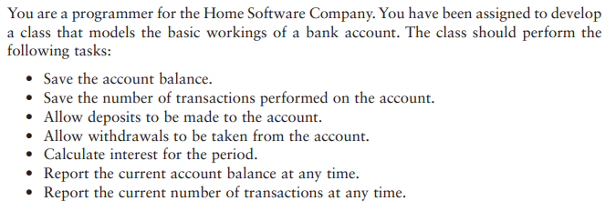





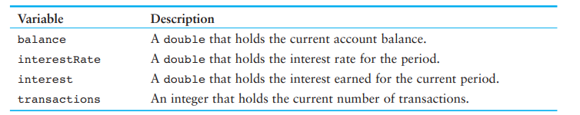







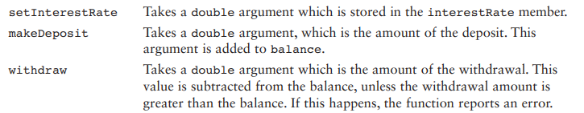

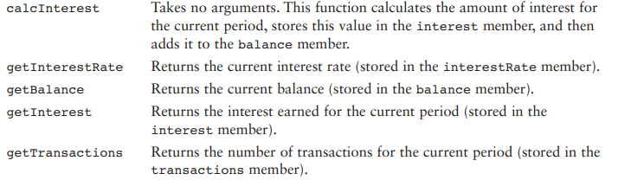

**Note: Must submit RollNo_Name.ccp file.**

**END**